PP Royal

Plastic Short Body Pillar Tap – Table Mounted (White)

**Product Description:**  
A compact and practical short body pillar tap made from high-grade plastic, designed for tabletop mounting in basins and sinks. Its minimalist all-white finish and easy-to-operate lever make it a perfect fit for modern homes and commercial use.

**Key Features (Single Line):**

1. Durable white polypropylene construction with glossy finish
2. Space-saving short body design suitable for compact areas
3. Smooth lever handle for easy water flow control
4. Corrosion-free, lightweight, and maintenance-friendly
5. Quick installation with threaded base and sealing washer

**Product Specifications:**

* **Material:** Virgin Polypropylene Plastic
* **Color:** White
* **Mount Type:** Table Mounted (Deck Mount)
* **Spout Type:** Short Angular Nozzle
* **Inlet Size:** ½ inch BSP (British Standard Pipe)
* **Handle Type:** Single Lever, Quarter Turn
* **Finish:** Glossy Surface Finish
* **Application:** Ideal for basin, wash area, or kitchen
* **Accessories Included:** Sealing washer and lock nut

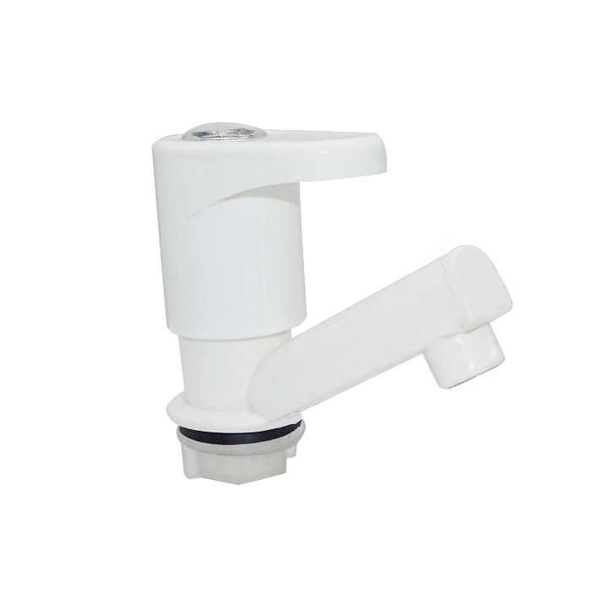

Plastic Swan Neck Tap – Wall Mounted (White)

**Product Description:**  
A sleek, swan neck plastic wall-mounted tap, perfect for kitchen or washbasin use, offering high arc water flow, ease of operation, and a modern design in a white finish with chrome detailing.

**Key Features (Single Line):**

1. Elegant swan neck design for easy container filling
2. Smooth quarter-turn lever operation
3. White body with chrome ring for a premium look
4. Wall-mounted for efficient space utilization
5. Durable plastic build, rust-proof and lightweight

**Product Specifications:**

* **Material:** High-grade Polypropylene Plastic
* **Color:** White with Chrome Accents
* **Mount Type:** Wall Mounted
* **Spout Type:** High Arc Swan Neck
* **Inlet Size:** ½ inch BSP
* **Handle Type:** Single Lever, Quarter Turn
* **Finish:** Glossy Surface Finish
* **Application:** Kitchen sink, washbasin, utility areas
* **Flow Type:** Smooth aerated water flow

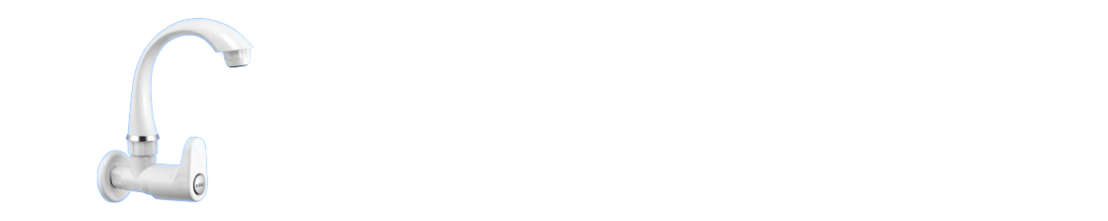

Plastic Swan Neck Pillar Tap – White with Chrome Ring

**Product Description:**  
A stylish, table-mounted swan neck plastic pillar tap with a high arc spout, ideal for kitchen sinks or countertops. Designed in a glossy white finish with a chrome ring accent, it combines durability with a clean, modern look.

**Key Features (Single Line):**

1. Elegant swan neck design allows easy pot filling
2. Sturdy table-mount base for hassle-free installation
3. Chrome accent ring enhances aesthetic appeal
4. Smooth lever handle for effortless water control
5. Made from high-quality rustproof plastic

**Product Specifications:**

* **Material:** Premium Polypropylene Plastic
* **Color:** Glossy White with Chrome Trim
* **Mount Type:** Table Mount / Pillar Mount
* **Spout Type:** Swan Neck, Fixed High Arc
* **Handle Type:** Quarter Turn Lever
* **Inlet Size:** ½ inch BSP
* **Finish:** Smooth Glossy Finish
* **Application:** Kitchen Sink, Utility Counter, Wash Basins
* **Water Flow:** Aerated, Splash-Free Output

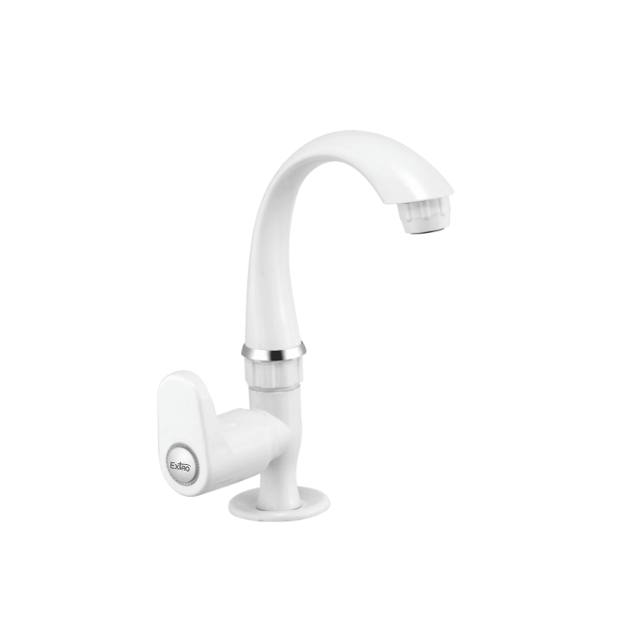

**Extro Short Body Bib Tap – Wall Mount (White)**

**Product Description:**

The Extro Short Body Bib Tap is a wall-mounted, minimalist water outlet solution designed for compact spaces. Its sleek profile and ergonomic lever handle offer style, reliability, and ease of use, making it ideal for utility areas and bathrooms.

**5 Key Features (Single Line):**

1. Compact design perfect for tight or low-use installations.
2. Durable plastic construction resists corrosion and wear.
3. Quarter-turn lever offers smooth and precise flow control.
4. Glossy white finish enhances any modern decor.
5. Easy wall-mount installation with standard inlet thread.

**Product Specification:**

* **Brand:** Extro
* **Material:** Virgin Polypropylene Plastic
* **Color:** White
* **Mounting Type:** Wall Mounted
* **Handle Type:** Single Lever, Quarter Turn
* **Inlet Connection Size:** ½ inch BSP
* **Finish Type:** Glossy
* **Application:** Washbasins, Utility Areas, Garden Taps
* **Flow Type:** Controlled, Splash-free stream
* **Weight:** Lightweight for easy handling and installation

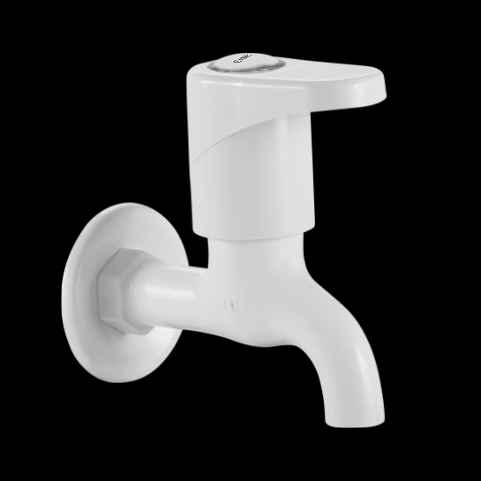

**Extro Long Body Bib Tap – Wall Mount (White)**

**Product Description:**

The Extro Long Body Bib Tap is designed for wall-mounted use where extended reach is needed, offering easy access to water flow over sinks or washing areas. It features a stylish, modern lever handle and a corrosion-resistant white finish ideal for utility and bathroom use.

**5 Key Features (Single Line):**

1. Long spout reach ideal for larger sinks or utility use.
2. Made from high-quality plastic for durability and rust resistance.
3. Ergonomic lever handle for smooth one-hand operation.
4. Sleek white glossy finish blends into modern interiors.
5. Easy to install with a ½ inch BSP wall connection.

**Product Specification:**

* **Brand:** Extro
* **Material:** Premium Grade Polypropylene Plastic
* **Color:** White
* **Mounting Type:** Wall Mounted
* **Handle Type:** Single Lever (Quarter Turn)
* **Spout Length:** Long body for extended reach
* **Inlet Size:** ½ inch BSP Threaded Connection
* **Finish Type:** Glossy White
* **Usage:** Utility Sinks, Bathrooms, Wash Basins
* **Flow Type:** Controlled Stream
* **Installation:** Tool-free basic wall mount installation

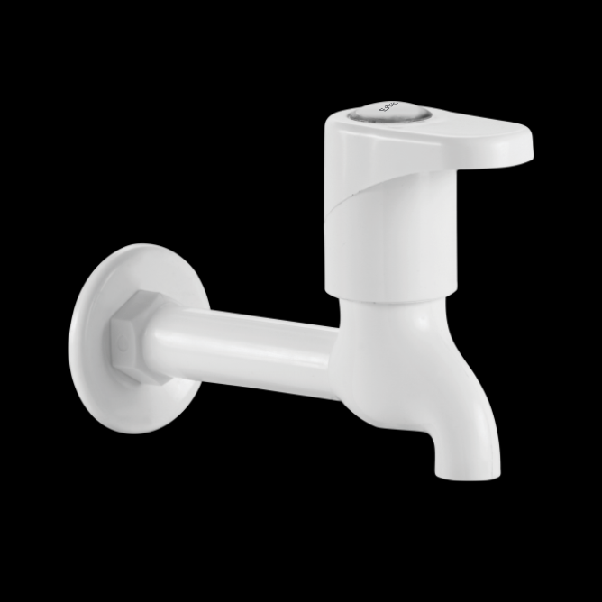

**Extro Angular Stop Cock (White)**

**Product Description:**

The Extro Angular Stop Cock is a modern, compact valve used to control water flow to connected fixtures like geysers, washing machines, and cisterns. Designed for wall mounting, it combines high functionality with a sleek, durable design suited for all types of interiors.

**5 Key Features (Single Line):**

1. Quarter-turn lever for precise flow control,
2. Rust-proof and corrosion-resistant body,
3. Wall-mounted compact angular design,
4. Ideal for geyser or appliance inlet connection,
5. Smooth handle operation with contemporary aesthetics.

**Product Specification:**

* **Brand:** Extro
* **Model:** Angular Stop Cock
* **Material:** High-Grade Polypropylene Plastic
* **Color:** White
* **Handle Type:** Single Lever (Quarter Turn)
* **Mounting Type:** Wall Mounted
* **Inlet/Outlet Connection:** ½ inch BSP Male Thread
* **Finish Type:** Glossy White
* **Application:** Suitable for water heaters, washing machines, flush tanks
* **Operating Mechanism:** Rotational shut-off valve
* **Installation:** Easy DIY installation with wall flange

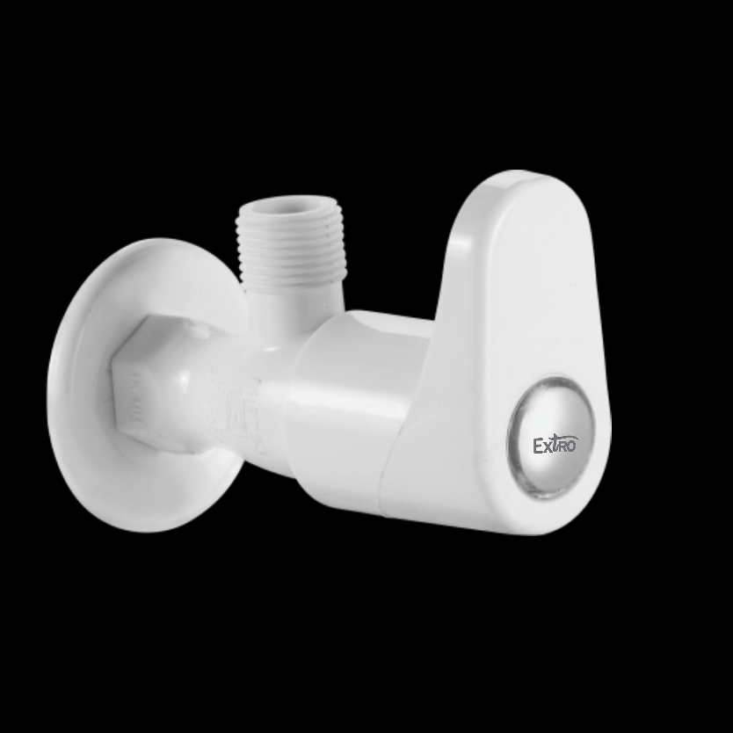

**Extro 2-Way Bib Cock (White)**

**Product Description:**

The Extro 2-Way Bib Cock is a dual-function wall-mounted faucet designed to control water flow from two outlets, ideal for connecting both a tap and an appliance like a washing machine or garden hose, providing convenience and versatility in modern plumbing setups.

**5 Key Features (Single Line):**

1. Dual outlet for simultaneous use,
2. Quarter-turn levers for easy control,
3. High-quality plastic construction for durability,
4. Smooth handle operation with leak-proof design,
5. Ideal for kitchens, bathrooms, or utility areas.

**Product Specification:**

* **Brand:** Extro
* **Model:** 2-Way Bib Cock
* **Material:** Premium-grade Polypropylene
* **Color:** White
* **Handle Type:** Dual Lever (Quarter Turn)
* **Mounting Type:** Wall Mounted
* **Inlet Connection:** ½ inch BSP Male Thread
* **Outlets:** One curved nozzle and one threaded utility outlet
* **Finish:** Glossy White
* **Application:** Suitable for washing machine, outdoor taps, bathrooms
* **Operation:** Dual control valves for independent use

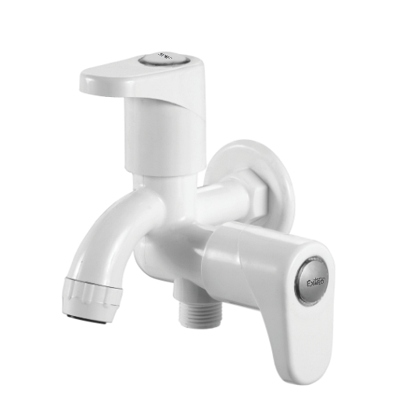

**Extro Angular 2-Way Bib Cock (White)**

**Product Description:**

The Extro Angular 2-Way Bib Cock is a multifunctional wall-mounted tap featuring two outlets and independent controls, ideal for connecting bathroom fittings like health faucets, washing machines, or garden hose pipes, ensuring both convenience and modern utility.

**5 Key Features (Single Line):**

1. Dual outlet design with separate controls for each,
2. High-grade polypropylene body for long life,
3. Ergonomic lever handles with smooth operation,
4. Compact angular form for space-saving installations,
5. Corrosion-resistant and leak-proof design.

**Product Specification:**

* **Brand:** Extro
* **Model:** Angular 2-Way Bib Cock
* **Material:** High-quality Polypropylene (Plastic)
* **Color:** White
* **Finish:** Glossy
* **Mounting Type:** Wall Mounted
* **Inlet Size:** ½ inch BSP Male Thread
* **Outlets:** Two (One angular side outlet, one bottom outlet)
* **Handle Type:** Dual lever (Quarter turn)
* **Application:** Bathrooms, utility areas, washing machine connections
* **Feature:** Independent operation for each outlet

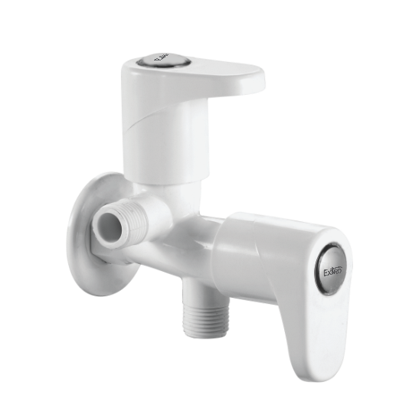

**Extro Nozzle Bib Cock (Hose Connection Type)**

**Product Description:**

The Extro Nozzle Bib Cock is designed with a specialized outlet ideal for hosepipe attachments, making it perfect for gardening, car washing, and utility areas where flexible water connections are required.

**5 Key Features (Single Line):**

1. Built-in nozzle spout for direct hosepipe connection,
2. Made from high-grade engineering plastic for durability,
3. Quarter-turn lever for easy on/off control,
4. Wall-mounted compact design ideal for outdoor and utility use,
5. Corrosion and weather resistant for long-term use.

**Product Specification:**

* **Brand:** Extro
* **Model:** Nozzle Bib Cock
* **Material:** High-quality Plastic (Polypropylene / PTMT)
* **Color:** White
* **Finish:** Glossy
* **Mounting Type:** Wall Mounted
* **Inlet Size:** ½ inch BSP Thread
* **Outlet Type:** Hose Nozzle
* **Handle Type:** Single lever (Quarter turn)
* **Application:** Garden, utility areas, garages, outdoor cleaning
* **Feature:** Compatible with standard hose pipes

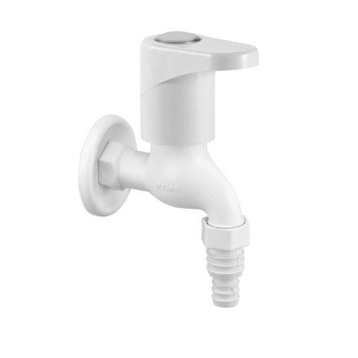

**Extro Swan Neck Wall Mounted Faucet**

**Product Description:**

The Extro Swan Neck Wall Mounted Faucet offers a sleek, modern design with a tall, curved spout ideal for kitchen and basin use, providing enhanced reach and clearance with reliable water control.

**5 Key Features (Single Line):**

1. Elegant swan neck design for extended reach and modern look,
2. Wall-mounted construction saves counter space,
3. Smooth quarter-turn lever for effortless control,
4. High-quality plastic build with glossy finish and chrome ring accent,
5. Suitable for kitchens, utility areas, and commercial sinks.

**Product Specification:**

* **Brand:** Extro
* **Model:** Swan Neck Wall Mounted Faucet
* **Material:** Durable Plastic (PTMT/Polypropylene)
* **Color:** White
* **Finish:** Glossy with Chrome Accent Ring
* **Mounting Type:** Wall Mounted
* **Inlet Size:** ½ inch BSP Thread
* **Spout Style:** Tall curved swan neck
* **Handle Type:** Single lever (Quarter turn)
* **Usage Area:** Kitchen sink, wall-mounted wash basin, utility area
* **Flow Type:** Normal aerated flow for daily use

